# Part 2: Practicing Normalization

## Exercise 1: Transforming Attributes

**The manager of a company dinner club would like to have an information system that assists him to plan the meals and to keep track of who attends the dinners, and so on.**

Because the manager is not an IS expert, the following table is used to store the information. As a member can attend many dinners and a member will not attend more than 1 dinner on the same date, **the primary key of the following table is Member ID and Dinner ID.** Dinners can have many courses, from one-course dinner to as many courses as the chef desired.

Member = customer

Dinner = meal

Venue = location

Food = specific food item

PK = MEMBERID + DINNERID

TEST: Does each attribute depend on both components of the Primary Key, or just a portion?

The manager of a company dinner club would like to have an information system that assists him to plan the meals and to keep track of who attends

the dinners, and so on.

Because the manager is not an IS expert, the following table is used to store the information. As a member can attend many dinners and a member

will not attend more than 1 dinner on the same date, the primary key of the following table is Member Num + Dinner Num. Dinners can have many

courses, from one-course dinner to as many courses as the chef desired.

MEMBER

NUM

MEMBER

NAME

MEMBER

ADDRESS

DINNER

NUM

DINNER

DATE

VENUE

CODE

VENUE

DESCRIPTION

FOOD

CODE

FOOD

DESCRIPTION

214 Peter Wong

325

Meadow

Park

D0001 15-Mar-10 B01

Grand Ball

Room

EN3 Stu ed crab

DE8

Chocolate

mousse

235 Mary Lee

123 Rose

Court

D0002 15-Mar-10 B02 Pe)t Ball Room EN5 Marinated steak

DE8

Chocolate

mousse

250 Peter Wong 9 Nine Ave D0003 20-Mar-10 C01 Café SO1 Pumpkin soup

EN5 Marinated steak

DE2 Apple pie

235 Mary Lee

123 Rose

Court

D0003 20-Mar-10 C01 Café SO1 Pumpkin soup

EN5 Marinated steak

DE2 Apple pie

300 Paul Lee

123 Rose

Court

D0004 20-Mar-10 E10 Pe)t Ball Room SA2 Apple pie

* This table has only 5 records.

a. Use proper notation to write down the above table. Use “Member Dinner” as the table name.

b. Convert the above Member Dinner table into 1

st

Normal Form table.

c. Assuming you can identify the functional dependencies from the table; draw a functional dependencies diagram

for the 1

st

NF table.

d. Develop a set of 3NF tables. Show every step of normalization along the way.

|  |  |  |  |  |  |  |  |  |
| --- | --- | --- | --- | --- | --- | --- | --- | --- |
| **MemberID** | MemberName | MemberAddress | **DinnerID** | DinnerDate | VenueCode | VenueDescription | FoodCode | FoodDescription |
| 214 | Peter Wong | 325 Meadow Park | D0001 | 02/02/2020 | L01 | Grand_Ball_Room | EN3 | Stu ed crab |
|  | | | | | | | DEB | Beef |
| 235 | Mary Lee | 123 Bellfower | D0002 | 02/02/2020 | L02 | Café | EN5 | Chocolate Mousse |
|  | | | | | | | DEB | Beef |
| 250 | John Doe | 9923 Orange | D0003 | 03/03/20 | L01 | Grand_Ball_Room | SO1 | Marinated Steak |
|  | | | | | | | EN5 | Chocolate Mousse |
| DE2 | Apple Pie |
| 235 | Mary Lee | 123 Bellfower | D0004 | 03/03/2020 | L02 | Café | S01 | Pumpkin Soup |
|  | | | | | | | SA2 | Marinated Steak |
| DE2 | Apple Pie |
| 300 | Paul Lee | 123 Bellfower | D0004 | 03/03/2020 | L03 | Petit_Ball_Room | SA2 | Marinated Steak |

1. **Is the above table considered a relation? Why or why not? Is it in any normal form? If so, which one?** *The above table is not considered a relation because it is not in any normal form. It would first need to be broken down into atomized parts if it were to be considered 1NF.*
2. Transform the table above into first normal form 1NF. (To do this, check if there are multivalued attributes and transform the table to get rid of them)

|  |  |  |  |  |  |  |  |  |
| --- | --- | --- | --- | --- | --- | --- | --- | --- |
| MemberID | MemberName | MemberAddress | DinnerID | DinnerDate | VenueCode | VenueDescription | FoodCode | FoodDescription |
| 214 | Peter Wong | 325 Meadow Park | D0001 | 02/02/2020 | L01 | Grand_Ball_Room | EN3 | Stu ed crab |
| 214 | Peter Wong | 325 Meadow Park | D0001 | 02/02/2020 | L01 | Grand_Ball_Room | DEB | Beef |
| 235 | Mary Lee | 123 Bellfower | D0002 | 02/02/2020 | L02 | Café | EN5 | ChocolateMousse |
| 235 | Mary Lee | 123 Bellfower | D0002 | 02/02/2020 | L02 | Cafe | DEB | Beef |
| 250 | John Doe | 9923 Orange | D0003 | 03/03/20 | L01 | Grand_Ball_Room | SO1 | Marinated Steak |
| 250 | John Doe | 9923 Orange | D0003 | 03/03/20 | L01 | Grand_Ball_Room | EN5 | Chocolate Mousse |
| 250 | John Doe | 9923 Orange | D0003 | 03/03/20 | L01 | Grand_Ball_Room | DE2 | Apple Pie |
| 235 | Mary Lee | 123 Bellfower | D0004 | 03/03/2020 | L02 | Café | S01 | Pumpkin Soup |
| 235 | Mary Lee | 123 Bellfower | D0004 | 03/03/2020 | L02 | Café | SA2 | Marinated Steak |
| 235 | Mary Lee | 123 Bellfower | D0004 | 03/03/2020 | L02 | Café | DE2 | Apple Pie |
| 300 | Paul Lee | 123 Bellfower | D0004 | 03/03/2020 | L03 | Petit_Ball_Room | SA2 | Marinated Steak |

* 1. Identify the dependencies and which type they are (full dependencies, partial dependencies, transitive dependencies.

1. Transform the table above into second normal form 2NF. (To do these separate partial dependencies into separate tables). Diagram

   Description automatically generated with medium confidence
2. Transform the table above into third normal form 3NF. (To do this, remove the transitive dependencies by creating separate tables and relate them with the common attribute)

## Exercise 2: Normalizing Grade Reports

Figure 4-4 shows a relation called GRADE REPORT for a university. Your assignment is as follows:

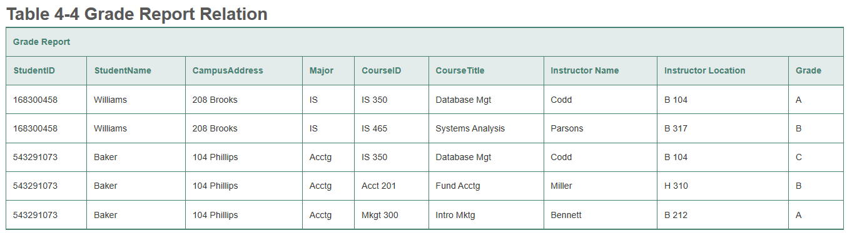

* 1. Draw a logical model for the table above, and graph and explain (with arrows) the functional dependencies in the relation.

* 1. In what normal form is this relation? *1NF*
  2. Transform the GRADE REPORT table into relations in 3NF.

* 1. Draw a model for your 3NF relations and show the primary key/foreign key relationships.

## Exercise 3: Normalizing a Shipping Manifest

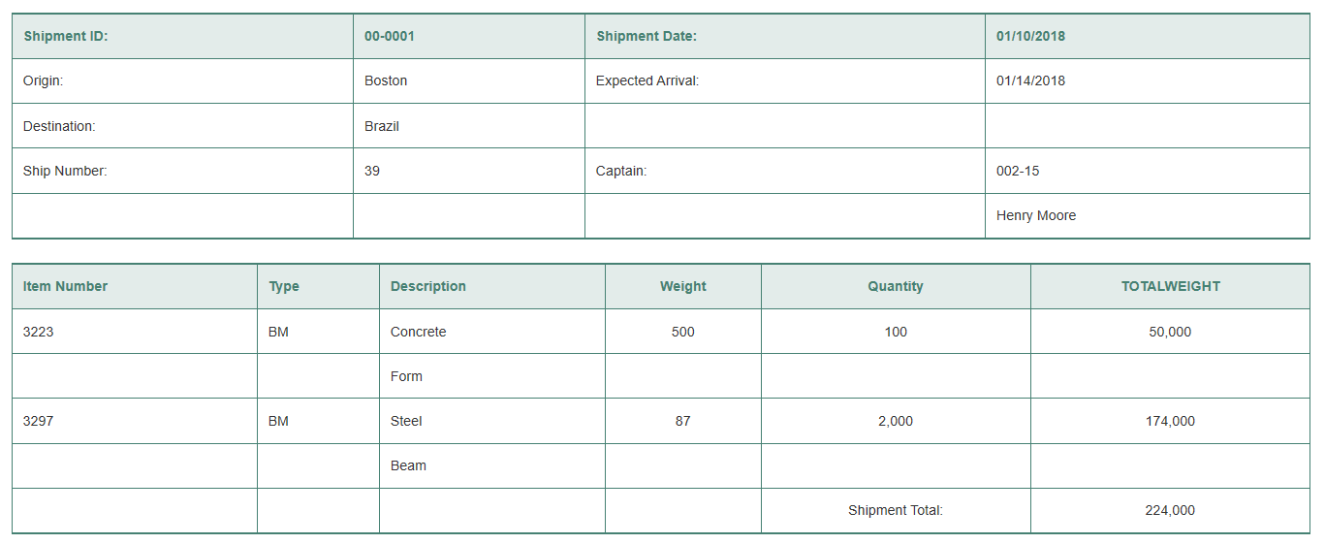Figure 4-5 shows a relation for a shipping manifest.

**NOTE:** This is all a single table.

* 1. Draw a relational schema and diagram the functional dependencies in the relation. Diagram

     Description automatically generated with medium confidence
  2. In what normal form is this relation? *This has no normal form.*
  3. Decompose MANIFEST into a set of 3NF relations. Diagram

     Description automatically generated
  4. Draw a relational schema for your 3NF relations and show the referential integrity constraints. *(See e)*
  5. Draw your answer to part d using Microsoft Visio (or any other tool specified by your instructor).

